ISAD251_cw_2019

Course work by Stephen Daniel 10585854

1. Storyboard (I had trouble to convert to Doc/jpg format please view the pdf)
2. ERD.
3. Peer review for storyboard and working app.
4. Application fact page.

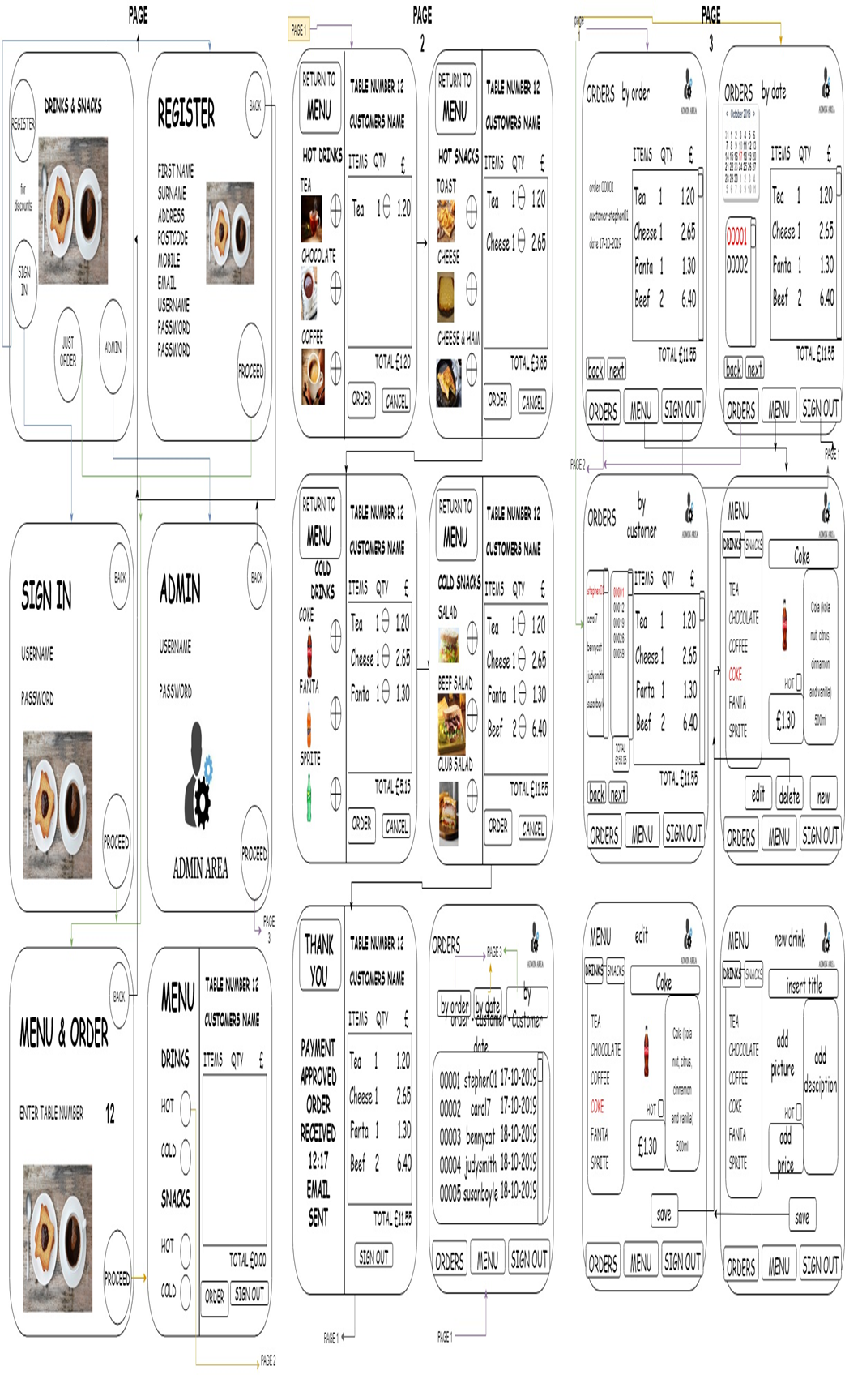

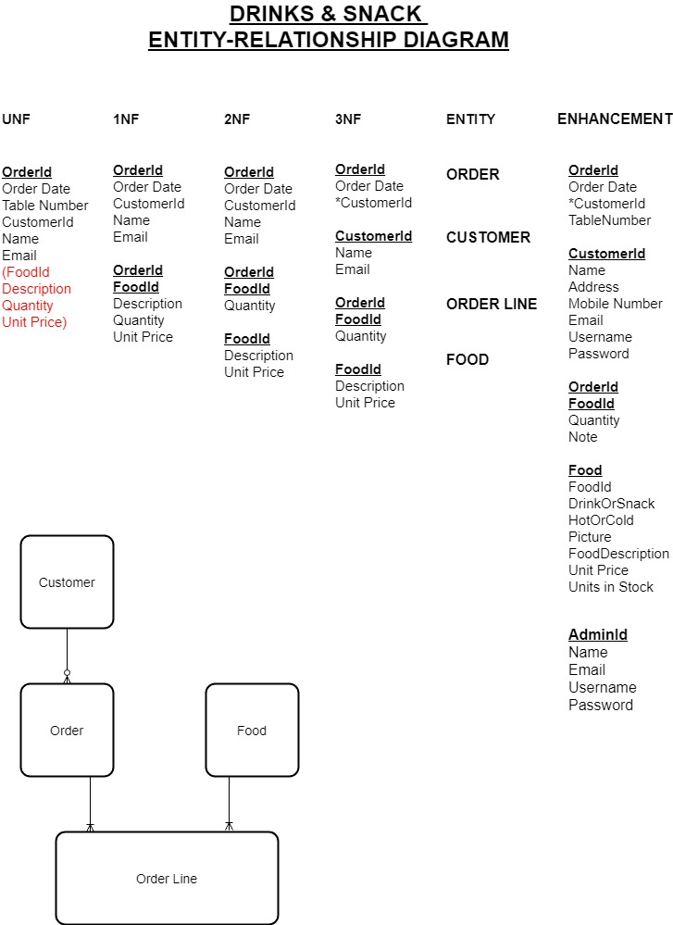

**Peer Review Template for the storyboard**

Peer Review carried out by: (name) Sophie Turner Date: 15-November-2019

The peer review should pick one of the user stories and attempt to use the application as that type of user carrying out that task. On completing using the application, you should ask the author to describe to you one aspect of the code implemented to run the task – eg the database structure or the server-side code.

Task conducted: (Please enter the user story)

To create a story board for the app to illustrate how my database has been constructed

Was the task easy to carry out? (If no or not really, please say why)

With the use of drawio I was able to clearly view all the proposed web pages along with uml diagrams showing progression of pages

Did you encounter any errors? (If yes, please explain what)

No, it all seemed to show the full app on paper

Did the author have to explain how to use anything? (If yes, what?)

Only at the begin to show the amount of pages and the lines drawn from page to page. After that it was easy to follow.

Did you gain any inspiration for your own practice? (If so what?)

The software that was used for this storyboard drawio is something that I would use from now on.

Looking at the ordering system look good as it wasn’t a shopping cart.

What constructive advice would you give the author for presenting their work/code in future?

I thought that the ordering though good would be better as a cart due to the use of the full screen to achieve this wouldn’t be useful on a mobile phone.

**Peer Review Template for the working app**

Peer Review carried out by: (name) Mike Holt Date: 06-January-2020

Task conducted: (Please enter the user story)

A working café app demo

Was the task easy to carry out? (If no or not really, please say why)

It was easy to carry out the task

Did you encounter any errors? (If yes, please explain what)

Error in the app where found. Spacing problems with words missing of screen, price amounts not

Showing and on some pages the nav buttons didn’t work

Did the author have to explain how to use anything? (If yes, what?)

No it seem good to pick up and use.

Did you gain any inspiration for your own practice? (If so what?)

The pictures of the food were great and I will need to follow that.

What constructive advice would you give the author for presenting their work/code in future?

To fix the problems found and try to follow a natural colour from page to page

**Fact sheet.**

Set up is to copy and paste the “web” folder to the localhost (xampp – ..htdocs/web)

Using the web browser go to address <http://localhost/web/index.php>

You tube video address. https://youtu.be/s7yOxj_0HmY

The video may be 5 minutes long, but I wanted to show both full screen and mobile phone screen abilities.

The CAFE 2020 has an in-house app that allows you the customer to order from your table.

A navigation bar that is found on the top of every page is an easy point and click to take you

to that page.

---------------------------------------------------------------------------------------------

**For the customers**

We have daily reading articles from local writers. these would be changed daily and allows

you to read while you are waiting for you order.

With a future option to register for discounts you would then have login details as a valid customer.

If you don’t want to sign up you can still jump straight in to order.

A large clear pictured menu awaits showing you the prices. All picked items are sort in you cart ready to order.

In the cart you can still add to what you have, delete any items or just go back.

In checkout an email would be sent to you to confirm the order and the time received.

----------------------------------------------------------------------------------------------

**For the owner**

The app also helps the owner with an in-depth admin selection

For this demo username == admin and password == password (that should never be used)

The admin will allow you full access to your database. With an easy to use GUI it is possible

to add, edit, delete any item, in any table of the database.

This section would not be shown to the public as only a correct username and password would take you

to the admin pages. The admin option in the navigation bar would be removed.

references to Third party software.

Xampp server <https://www.apachefriends.org/index.html>

MYSQL work bench <https://www.mysql.com/products/workbench/>

obs studio https://obsproject.com/download

phpstorm https://www.jetbrains.com/phpstorm/

Bootstrap https://getbootstrap.com/

phpmaker https://phpmaker.dev/doc/hh_start.htm

w3schools https://www.w3schools.com/

University of Plymouth https://www.plymouth.ac.uk/

Lenovo https://www.lenovo.com/gb/en/

Microsoft Office https://products.office.com/en-gb/word

youtube https://www.youtube.com/

**Screenshots of the app in Fullscreen and mobile screen.**

